  - 

Panel Title:

“Reimagining Climate Finance in Southeast Asia: Gender, Power, and the Politics of Climate Actions”
Convener : Irma Nugrahanti (PhD researcher at International Institute of Social Studies, the Netherlands).
Email : nugrahanti@iss.nl
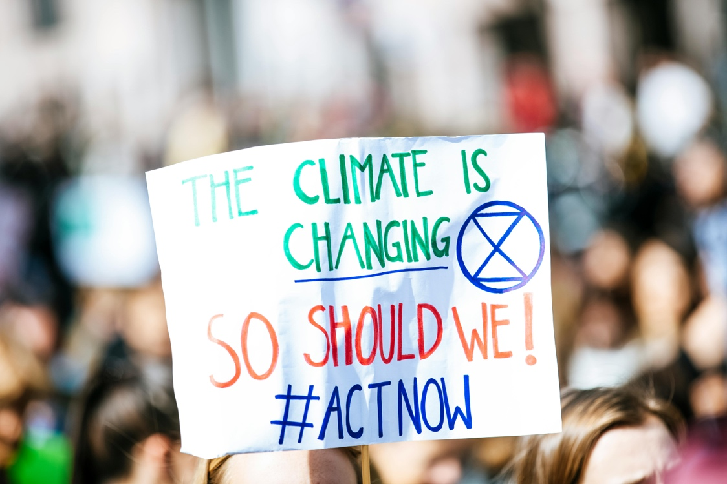
  - Proposed Format
This 90-minute panel will consist of four academic paper presentations, each lasting 15 minutes, followed by a 15-minute response from the discussant and an open Q&A session. This format promotes academic discourse and audience interaction. The panel aims to critically examine climate finance mechanism in Southeast Asia from feminist, intersectional, and decolonial perspectives. This panel emphasizes the power relations, gender lens, and political ideologies inherent in climate finance policies, governance frameworks, and implementation strategies, despite the common portrayal of climate finance in technocratic or market-oriented terms. The panel fosters important discussions on the mobilization of climate finance and invites critical conversations on how climate finance is mobilized, who shapes it, who benefits from it, and who is left out.

Description
Climate finance has become a fundamental component of both national and international responses to the climate crisis. In Southeast Asia, the allocation of climate funding is often influenced by power imbalance, political interests, gender-blind policy instruments, and persistent colonial legacies in development finance. This panel examines how climate finance, encompassing state budgets, international climate funds, and private sector investments, both influences and is influenced by the wider political, economic, and social landscapes in the area.
Utilizing critical development studies, feminist economics, and decoloniality, the panel poses the following question:
- How do gendered power structures, historical and systemic inequalities influence access to climate finance?
- What role do national budgets, donors, and multilateral institutions play in shaping priorities?
- How are Indigenous, local, and community-led climate solutions funded, or excluded?
- What alternative models exist for financing equitable and just climate transitions?
Panelists will utilize case studies from Southeast Asia countries to examine how climate financing may either perpetuate existing disparities or function as an instrument for transformational justice. The panel seeks to redefine climate financing as not just technical or economic tool, but also political process, where decisions over distribution, recognition, and involvement influence the region's climate futures.
Discussant:
Prof. Diane Elson (Economist, Sociologist and Gender and Development Social Scientiest) at University of Essex. A leading feminist economist known for her contributions to gender-responsive budgeting and the political economy of care and development.

