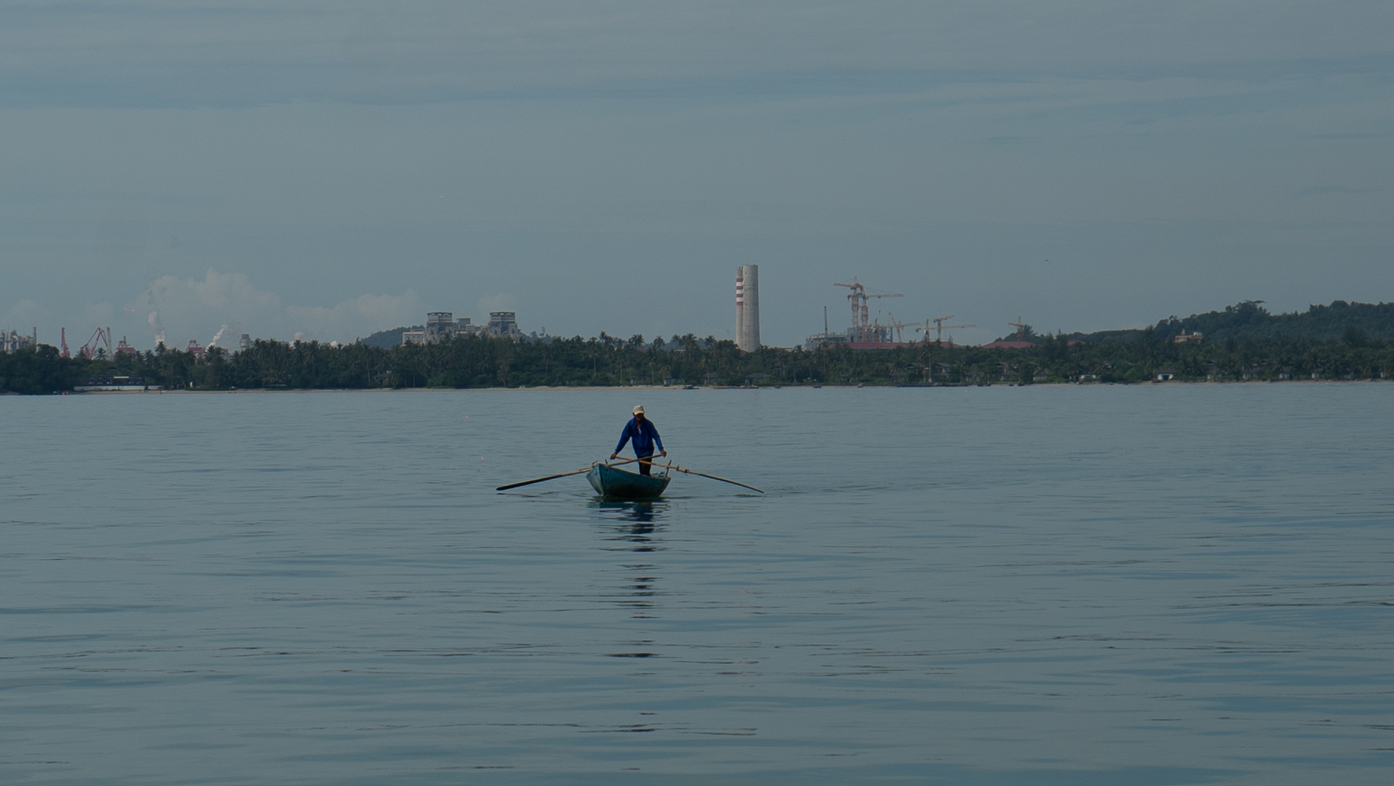
Mambang Kuneng: Listening to the Sea with Orang Laut
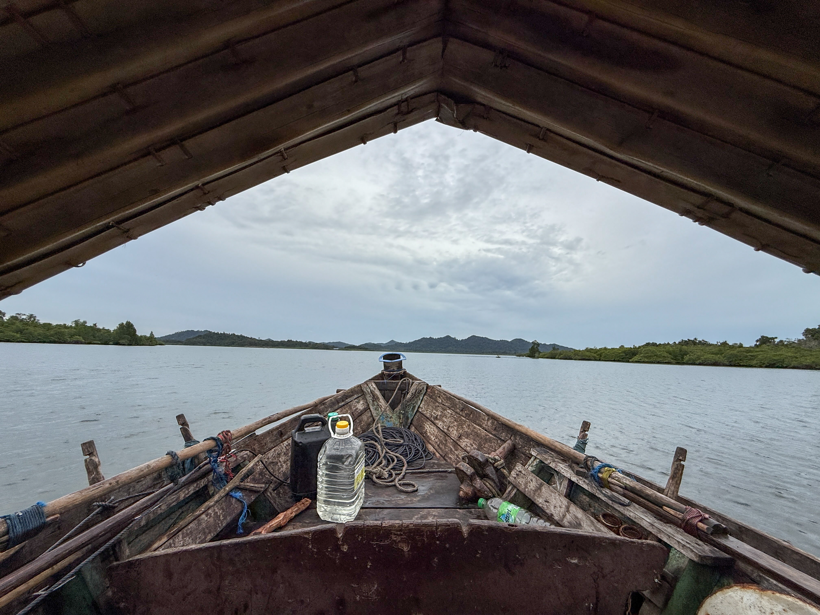
Images taken during field trip in the Riau Islands, Indonesia.
Credits: Wengki Ariando and Putra Gema Pamungkas.
- Co-Conveners

Di Fang (Artist-Researcher)
In-Depth-Space/Independent, the Netherlands
d.fang1991@gmail.com

Wengki Ariando (Researcher)
Royal Netherlands Institute of Southeast Asian and Caribbean Studies -KITLV, the Netherlands
wengki@kitlv.nl

2. Topic

The urgency of this topic is two-fold: first, to highlight the endangered traditional lifeways of the sea nomads (Orang Laut); and second, to explore new ways of documenting research that embrace embodied and situated knowledge systems.

In recent years, extractive development has expanded into the coastal zones and seas of Insular Southeast Asia, which are the primary domain of sea nomads such as the Orang Laut. In the Riau Islands Province of Indonesia, Orang Laut communities face mounting pressure from modernization, squeezed from both land and sea. Industrial growth has reclaimed coasts, polluted waters, cleared mangroves, and disrupted sacred geographies. These conditions are not isolated but echo across Southeast Asia, where Indigenous maritime communities struggle with habitat loss, cultural erasure, and systemic marginalization within land-based governance frameworks.

The film is born from a collaborative research trip uniting an artist, social scientists, Orang Laut knowledge holders, and a local journalist. The journey was both interdisciplinary and intersubjective — weaving facts, myths, and emotions into shared experiences that cannot be captured by academic writing alone. Through daily encounters, shared meals, and a co-led listening and recording workshop with Orang Laut friends, the film documents embodied Indigenous knowledge and lived maritime cosmologies. It follows the Orang Laut to traditional grounds now clashing with the industrial expansion of mining factories, to households resisting encroachment while treasuring the sea as home, and to underwater sonic worlds near industrial zones, seeking to preserve acoustic experiences on the verge of disappearance.

Mambang Kuneng is known among the Orang Laut in Riau Islands as a sea spirit who teaches respect for the sea, the land, and other-than-human beings. This reverence permeates their everyday lives and exemplifies an alternative way of coexisting—countering the dominant, extractive, and binary understanding of the human–nature relationship underpinning today’s planetary crisis.

This film is more than a record of struggle; it foregrounds the community’s fragile yet profound knowledge systems—wisdom that guides them through unpredictable seas, coexistence with dangerous creatures, and migration across shifting waves. These are not archives of the past but living, adaptive epistemologies that offer alternative ways of sensing and coexisting with the sea. In the face of accelerating modernization and flows of capital, how can such knowledge and intangible heritage endure?

The film’s artistic approach also challenges conventional ethnographic representation by adopting a more-than-human perspective — told, imaginatively, through the eyes and movements of a crocodile, a spiritual figure in local cosmology.

3. Discussion Format and Participants

The 20 to 30-minute film screening will be followed by a 60-minute moderated discussion on the topic “Listening, Knowledge, and the Sea: Indigenous Epistemologies and Artistic Fieldwork”.

The conversation will focus on two intertwined questions:
- how Indigenous maritime knowledge systems can engage with or expand contemporary conservation frameworks
and
- how artistic filmmaking can operate as a method of field research, amplifying embodied knowledge and sensory experience beyond conventional ethnographic forms.

The discussion aims to bring together perspectives from art, anthropology, and environmental policy, exploring how creative and community-based practices can support the visibility and protection of Indigenous maritime heritage. The discussants represent a diverse array of backgrounds and comprise members of the Orang Laut communities from Riau Islands. The details are as follows:

  - Dedi Supriadi Adhuri (Maritime anthropologist, National Research and Innovation Agency of the Republic of Indonesia, BRIN)
  - Johanes Jamil (Orang Laut from the Riau Islands)
  - Ida (Orang Laut from the Riau Islands)
  - Pia Duran (Independent filmmaker specializing in working with marginalized communities in Southeast Asia)

