EUROSEAS 2024 Paris - Proposal
Screenings with academic discussion
Title: Kajang: Otto Siddharta and the Art of Listening
Convener/ Filmmaker:

Dr Jean-David Caillouët
Lecturer and Researcher
Princess Galyani Vadhana Institute of Music, Bangkok.
jd@pgvim.ac.th
0066(+)899828603
Prof. Otto Sidharta
Dr. Otto Sidharta
Composer
ottosidharta@yahoo.com
Chairman of Indonesian Composers Association, Mahasvara Nusantara.

Topic description / abstract:

Otto Sidharta is widely recognised on the international stage as one of the pioneers of electronic music in Indonesia. His journey began in 1979 when he delved into experimental tape techniques and integrated environmental elements into his compositions. Notably, his 1979 piece "Kemelut" was entirely based on water sounds. Subsequently, he ventured to Nias Island in the Kalimantan (Borneo) jungle and the Riau Islands, collecting nature and animal sounds that would later influence his works, such as the 1985 piece 'Ngendau,' shaped by the materials and philosophies of the ethnic groups he encountered. Sidharta's innovative approach often draws inspiration from natural processes and deeply rooted local philosophies, which find expression in his collaborative projects with choreographers and dancers.

His exposure to new perspectives on music and sound originated from the teachings of Salmet Abdul Sjukur, an influential composer who studied in Paris and introduced radical ideas that revolutionized musical thinking in Indonesia. Born in 1955 in Bandung, Otto Sidharta pursued music studies at the Jakarta Institute of Arts (Institut Kesenian Jakarta) and completed his postgraduate studies at Sweelinck Conservatorium in Amsterdam under the guidance of Professor Ton de Leew. He further earned his doctoral degree at Institut Seni Indonesia Surakarta.

This documentary film explores the philosophical and cultural dimensions integral to Sidharta's expansive and diverse repertoire, with a specific focus on the Indonesian perspective. The presentation in Amsterdam, where Otto Siddharta spent formative years as a student, adds an additional layer of significance to the cultural reflections presented here.
discussion format and participants:

The format proposed for the presentation is as follows:

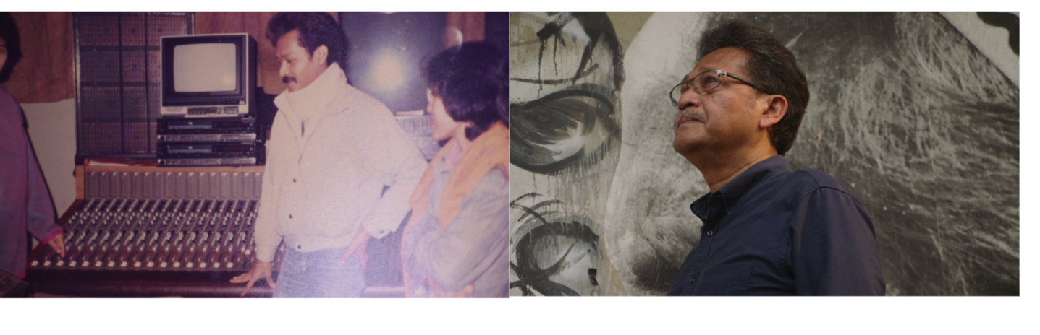
A short introduction to the film, highlighting the main themes and issues covered through its narrative, a showing of the film (2 possible versions are available: 70 mins or 40 mins depending on the conference requirements; a shorter edit may also be provided if necessary) followed by a discussion and Q&A with the artist Otto Siddharta and the filmmaker Jean-David Caillouët.
